Units
1. Infantry. All infantry travel at foot speed which is slow (3 hexes in most terrain, 4 in road), but they do not have as many movement penalties in rough terrain. Level I attacks twice, Level II 3 times, Level III 4 times and Level IV 5 times per round. All infantry require a manpower point to build. They also have limited bridge blow points.
a. Infantry I-IV. This is the basic unit. Doubled on the defense in non-clear terrain. Higher bonus in cities and fortifications.
b. Assault Infantry has a represents shock troops, mortar platoons, etc… Costs more, defends as Infantry, 50-100% bonus on offense depending on the terrain type.
c. Elite Infantry. Even more expensive. Fights as assault infantry. Moves 25% faster and can be para dropped. Has better recon and hiding ability. Can also carry more supply. Additionally requires a specialist point to build.
d. Partisans. Cannot be built but appear in Axis occupied territories under certain conditions. Use less supply, not to effective in combat. Better movement, hide and recon than infantry.
e. Conscripts. Cheap. Fights like infantry but only 1 attack per round.
f. Engineers. Fights like infantry but also has build points and more bridge blowing points. Additionally requires a specialist to build.
g. Staff I-IV. Ineffective in combat. Has 50 staff points. Combat and morale modifiers increases with level.
h. Named leaders. Single units with 100 staff points. Combat and moral modifiers equivalent to Staff V. Cannot be built. Includes Rommel, Manstein, Guderian, Kesselring for Germans; Montgomery, O'Connor, Bradely and Patton for the West. Zhukov, Koniev and Rokossovky for the Soviets (Tukhachevshy available if Soviets do not have a purge)
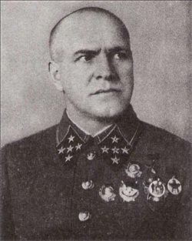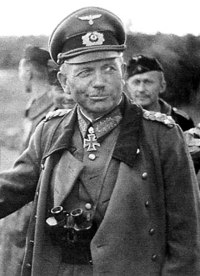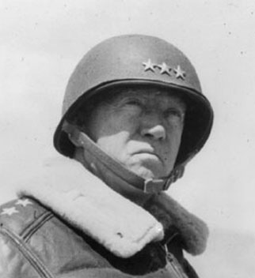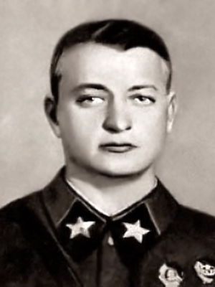
i. Horses. A horse will carry 1 infantry or 1 gun at slightly higher speed.
j. Worker battalions. Very cheap labor. Engineering stats similar to engineers but quite ineffective in combat.
2. Guns. Guns are scaled down from the based AT version, so having 10 or 20 in a unit is not unusual. The cost and effectiveness is similar to infantry. Guns require Steel as a precursor to build. Artillery counter battery is turned on (e.g., artillery fires back). Like infantry, higher levels of guns have more attacks. Artillery all moves at foot speed.
a. Artillery (Light and Heavy). Similar to base AT. Heavy artillery is 2/3rds more powerful. Artillery is key in wiping out defensive positions prior to an assault. Artillery has a range of 1. Note that bridges or more fragile so any serious bombardment will drop neighboring bridges.
b. AT guns. Particullary effective vs tanks
c. Flak. Particuallary effective vs planes
3. Vehicles. Vehicles are also scaled down from AT. All vehicles require Engines to build. Armored vehicles require Steel as well. Vehicles move quickly using wheel, tracked or rail movement.
a. Trucks and halftracks. These units can carry 1 infantry or 1 gun. Trucks only require engines while halftrackes require engines and steel. Halftracks have twice the defense of trucks and better recon. A few halftracks are shown below:
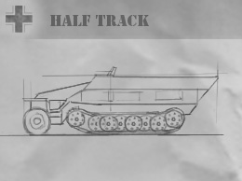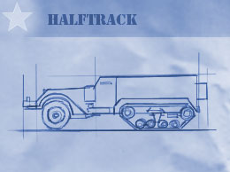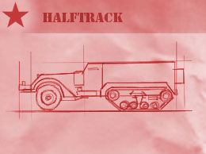
b. Trains. Trains have good rail cap and are primarily used from strategically transfering units about the map.
c. Tanks. Tanks require both engines and steel. There 5 types of tanks. Obsolete (or prewar tanks), Light Tanks, Medium Tanks, Heavy Tanks and Tank Killers. The offensive and defensive power rises from Light to Medium to Heavy Tanks. Tank Killers have the offensive power of Heavy Tanks with the defensive power of Light Tanks. Tanks are very effective in plains having a 100% offensive and defensive power modifier. Attacks get considerably weaker as the terrain gets rougher. Light Tanks also have a movement bonus and a better recon. Tanks are also scaled down from AT so stacks of 10 to 20 are not unusual. Tanks no longer can carry infantry. If you want to keep infantry with an armor unit, make sure to include trucks or halftracks. Higher level tanks have more attacks (like infantry and guns). Note that Japan and China cannot build Heavy Tanks or Tank Killers. Obsolete tanks are 50% less effective than light tanks.
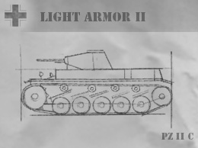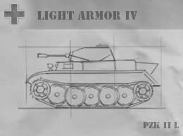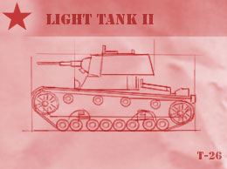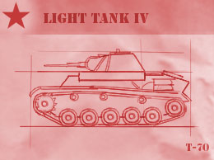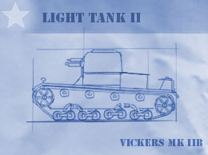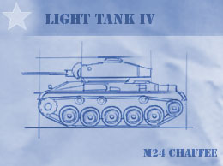
4. Planes. Planes are also scaled downed from AT. Standard formations have 10-20 units. Planes require both Pilots and Engines to build. There are 4 types of planes: Fighter, Dive Bombers, Level Bombers and Naval Air. Planes are more fragile than in AT so expect higher losses when attacking.
a. Fighters. Similar to AT. They are good for establishing air superiority and have good recon. Higher levels get more attacks and have better range.
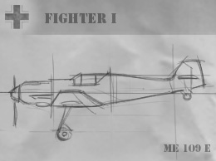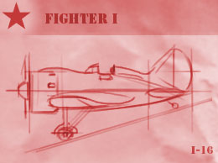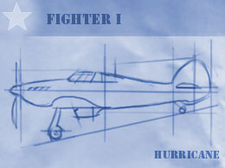
b. Level Bombers. Really long range (20 hexes) and improves with leveling. Good at destroying structures which also improves with leveling. Can also carry paratroops.
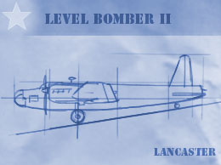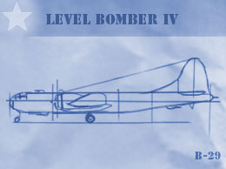
c. Dive Bombers. Good for ground attacks.
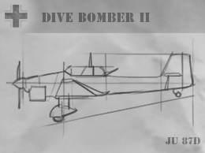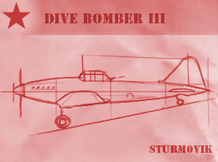
d. Naval Air. Good for command of the seas. Can operate from carriers. Not available to Soviet or Chinese.
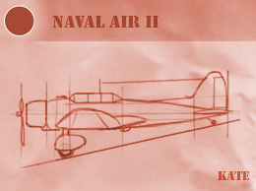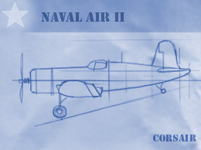
5. Ships. There are 6 ship classes. DD, CG, BB, Cargoships, Subs and Carriers. All ships require Hulls as a precursor to build. Combat ships have more attacks with levels. CV's can carry more planes as they level.
a. Cargo Ships. Perform similar role in AT. They can carry 20 infantry and fewer tanks.
b. Destroyers. Good for Sub hunting. Have better speed and recon.
c. Cruisers. Good against DD and as a protection vs planes. Limited shore bombardment.
d. Battleships. Good against all surface ships and good as a shore bombardment platform.
e. Submarines. Good at interdicting supply. Effective vs capital ships.
f. Carriers. Note that the Soviets and Chinese cannot build. Level I can carry 4 Naval Air, Level II can carry 6 Naval Air, Level III can carry 8 Naval Air and Level IV can carry 10 Naval Air.
Back to WAW Scenario

