Minor Country Activations
General rules for coups. Only attempted once. Only attempted before a minor nation joins a side. Play via diplomatic research. 25% chance to succeed / 10% chance for a counter coup.

Allied Minors

1. Poland
In the standard game, Poland is Germany's first battle. The 'No Munich' variant starts the war with the invasion of Czechoslovakia. Poland can then be attacked by either Germany and the Soviet Union. Both can also pledge support to Poland. If Germany attacks and Poland is not supported by Russia, the battle is the same as the normal game. If Germany attacks and Poland is supported by the Soviets, then Poland joins the Soviet Union and Germany is immediately at war with both. If the Soviets attack and Poland is not supported by Germany, then Poland is partitioned. If the Soviets attack and Poland is supported by Germany, then Poland immediately joins Germany and now the Soviet Union is at war with both. An attack on Poland by the Soviets is a way for the Soviets to get around the issue of initiative, but Soviets give the Germans' a sizeable if somewhat ineffective army to the East.
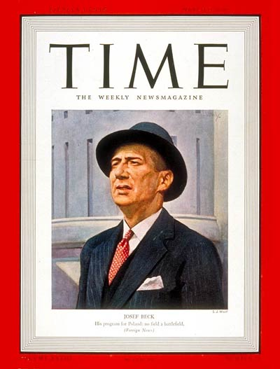

2. Czechoslovakia
Czechoslovakia only exists if the “No Munich” variant is played. It immediately joins the West and as at war with Germany. This variant starts the war in 1938.
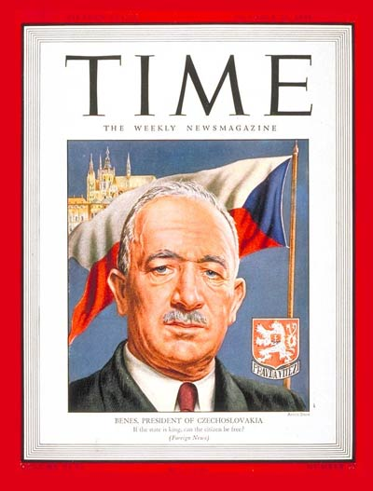

3. Denmark / Norway
Denmark / Norway is a combined regime. Germany can research a coup (successful 25% of time, counter coup 10% of time). The Swedish Iron Ore resource will help the German economy. Note that if Germany occupies Bergen, Allied lend lease to the Soviet Union is more expensive. Denmark / Norway will join the West if Germany declares war. If the “No Poland” variant is played (Poland already partitioned between the Soviets and Germans) and the “No Munich” variant is NOT played, then the game starts in 1940 with a German attack on Denmark / Norway.
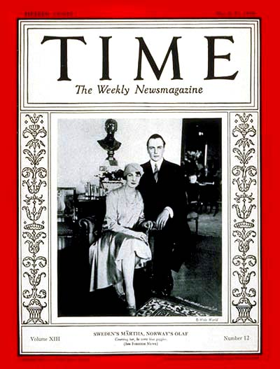

4. BeNeLux
Belgium, Netherlands and Luxemborg are combined. Germany declares war by playing the Western Blitz action card. This drops paras in both Belgium and Netherlands, inflicts a 50% readiness penalty and also moves elements of Army Group 3 into Belgium. A variant makes Belgium and France allies, in which case Netherlands remains independent. Once the Germans launch the offensive, the Dutch East Indies comes under the control of the United States. Prior to Japan entering the war vs the West. the British can play a card that brings the DEI under their control. This allies the West to militarize the DEI.
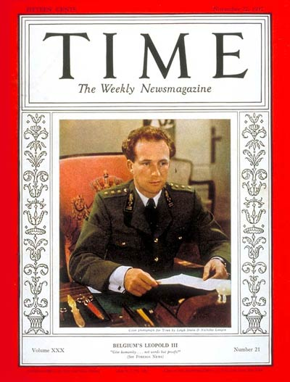

5. Greece
The West can play a card to have Greece join after the fall of Paris. Germany can also attempt a coup at this time or declare war on Greece. Note that the “Greece defeats Turkey” variant gives Greece control of the Bosphorus and Dardanelles. If this occurs and Germany succeeds at a coup or declares war, the Soviets get a 20 point initiative increase (same as if Germany attacked Turkey). If the Allies bring Greece into the war, their is no Soviet initiative impact if the Germans later capture the straits.
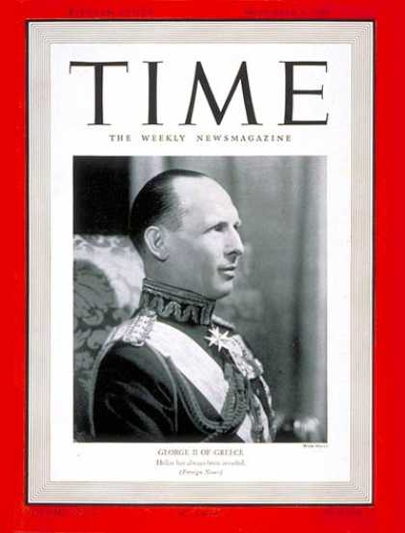
Back to WAW scenario

Latin America

Mexico, Brazil and Argentina
May join the conflict. Germany may launch a coup attempt against each with a 25% chance of success and a 10% chance of a counter coup. Coups' against Brazil and Argentina may played any time. Mexico may only be attempted after the US goes to war. Once the US is at war, the Allied player may attempt to bring them into the war through diplomatic research. If this is played, there is a 10% chance per round that these countries declare war on the Axis. Effectively, Germany could spend 100 pp early in the game for a coin flip that will give them great bases to interdict supplies with U-Boats.
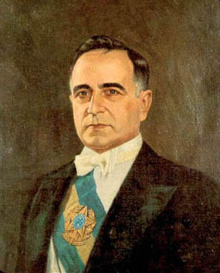
Back to WAW scenario

Axis Minors
All Axis Minors, otherwise neutral, immediately join the war on the side of the Axis when Germany goes to war with the Soviets

1. Finland
After France falls, may join the German side via an action card. Soviets may also claim the border hexes via the Winter War card. If the Finns join the Axis side and the Soviets did not play the card, the Soviets lose the card but gain 10 initiative points. If the Finns join after, there is no impact on Soviet iniative.
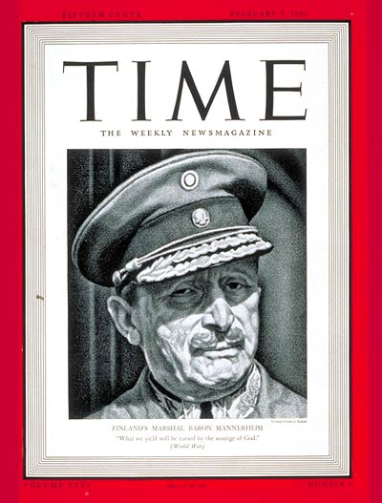

2. Romania
After France falls, may join the German side via an action card. Soviets may also claim the border hexes vis the Moldova card. If the Romanians join the Axis side and the Soviets did not play the card, the Soviets lost the card but gain 10 initiative points. If the Romanians join after, there is no impact on Soviet iniative. The West may try a coup after the fall of France.
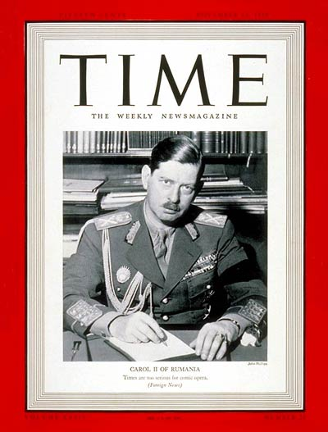

3. Hungary, Yugoslavia, Bulgaria
All may join the German side after France falls by individual action card. Each joining raises Soviet initiative by 10. The West may likewise make a coup attempt on Each. Note that the Germans have to consider their strategy in bring in minors. The Soviets' need 50 initiative points to attack Germany a fast mobilization in the East could see an early entry into the war.
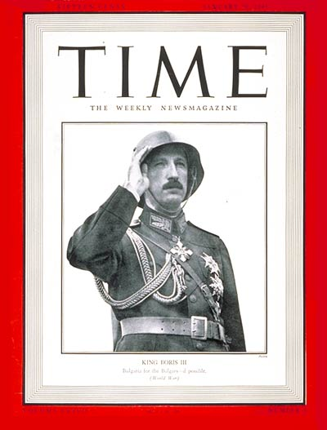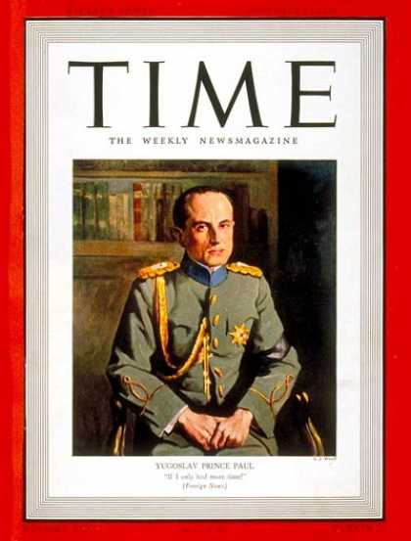
Also note that this a significant departure from most WWII games where a pro-Allied coup is hard coded for Yugoslavia. The design principle was that the coup was an usual event. It is likely that the West can cause a coup in at least 1 Balkan country. It is not certain which one it will be.

4. Thailand
Thailand is a Japanese minor that joins the Axis side when Japan enters the war against the West. The West may attempt a coup in Thailand after the fall of France.
Back to WAW scenario

Other Minors

1. Turkey
Germany and the Soviets can declare war on Turkey. If the Germans attack and they are not at war with the Soviets, Turkey joins the West and the Soviet initiative increases by 20. If the Germans attack and they are at war with the Soviets, Turkey joins the Soviets.
If Germany occupies Baghdad, it receives a card that allows it to bring Turkey into the war. If played, this will increase Soviet initiative by 20.

2. Spain
Both the West and Germany can declare war via action card after the fall of France. Prior to this, Spain will provide Aid to Germany once at war with the Soviet Union provided:
a. Germany still holds Paris and
b. Less than Western 50 power points are in Italy south of the Genoa / Bologna line.
When Spain gives Aid to Germany, a corridor from Bordeaux through Zaragoza to Madrid opens up. Germany can use Madrid and Zaragoza production. Germany can uses the Spanish units (e.g., the Blue Division). German units can also move to Madrid.
Germany can declare war on Spain while Spain is giving aid. If this occurs, any Axis units in the Spain corridor immediately move to France. Spain will then join the West. Note that Spain will fully join Germany if the West declares war on Spain. Also note that if the West enters the Spanish corridor controlled by Germany, this triggers a DOW by the West against Spain.

3. Indochina
Indochina is normally a colony of France. Once France fails, Japan can seize Indochina by playing an action card. The Western units in Indochina flee to Singapore and US initiative increases by 10.
A variant makes Indochina independent. Japan can declare war on Indochina once the war with China is resumed. Indochina will join China and US initiative increases by 10.

4. India
India is normally a colony of the West. Once Japan awakes, they can support the Indian National Congress via research. Once supported, there is a 25% chance per round that a general strike in India will occur. This causes all the locations in India (including Pakistan and Bangladesh) to become non-producing. Once the strike starts, there is a 25% chance per round that the strike ends and normal production resumes.
Back to WAW scenario

