Load Scenerio “tutorial2” from the classic_tutorial folder in the ATgoldscenerios folder. Leave both regimes control to “human”. You will play both sides.
Your screen should appear as below.
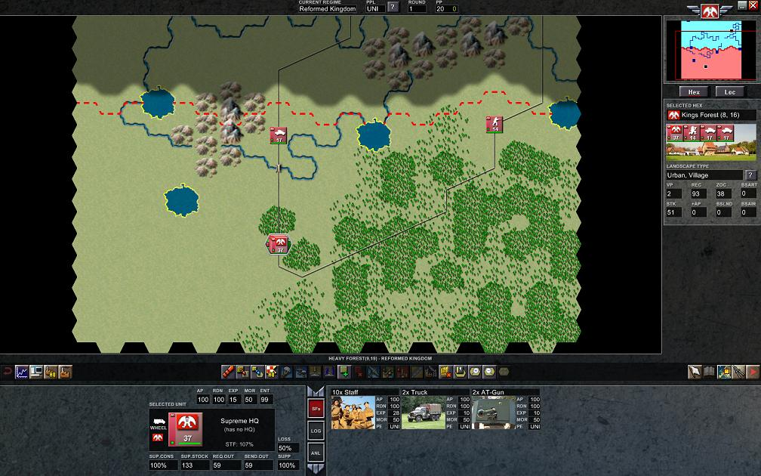
We want to find and destroy the opponents army. Move you forward units along the roads to locate the enemy. The 5th Division on your right sees the enemy but cannot move farther. The 2nd Div, armored car formation still has 60 AP (action points) after finding the enemy. We should try a probing attack to see if it is weak. Set the “Loss” box for this unit to 25% so it will retreat before taking many casualties.
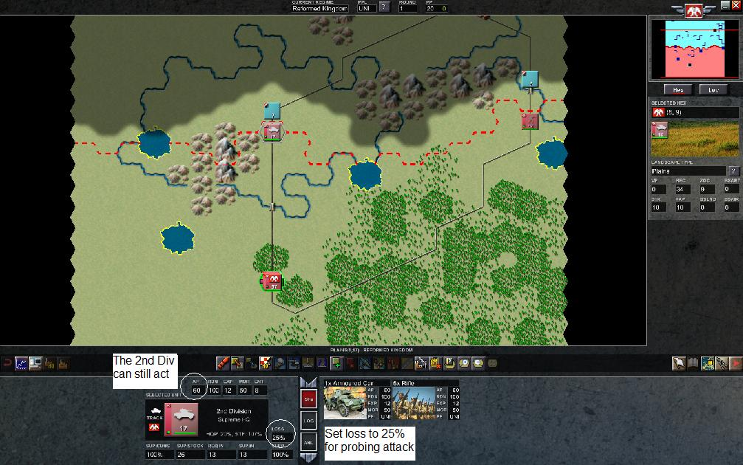
Attack the unknown blue unit with the 2nd Division to learn about the enemy unit. We took some losses, but we now know that we are facing a strong infantry unit. The bazooka presents a concern for our armored car. Another thing to note is that the unit is walking, so it will move relatively slowly compared to formations that have enough horses, tracked vehicles or trucks to ride.
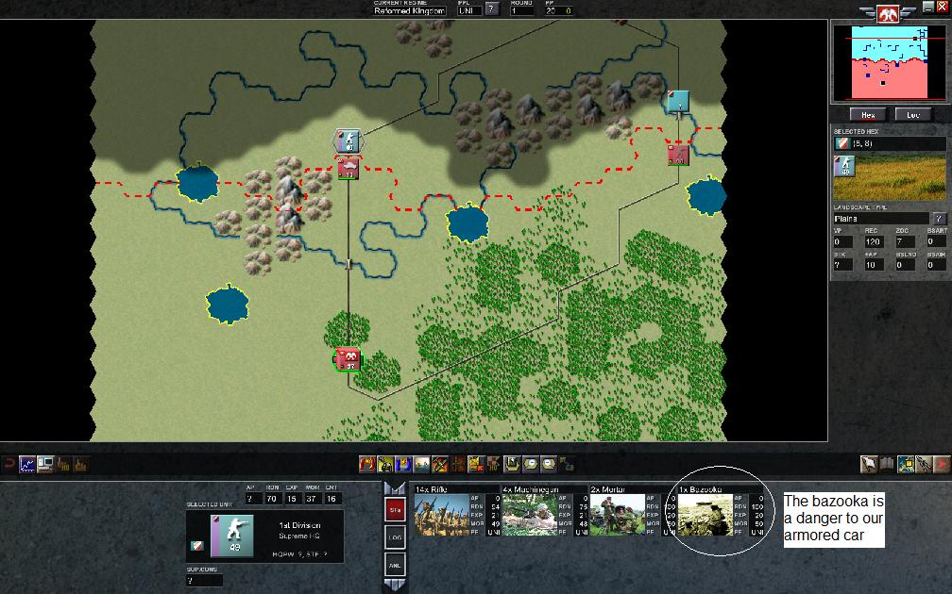
Right click on the picture of the bazooka to learn more.
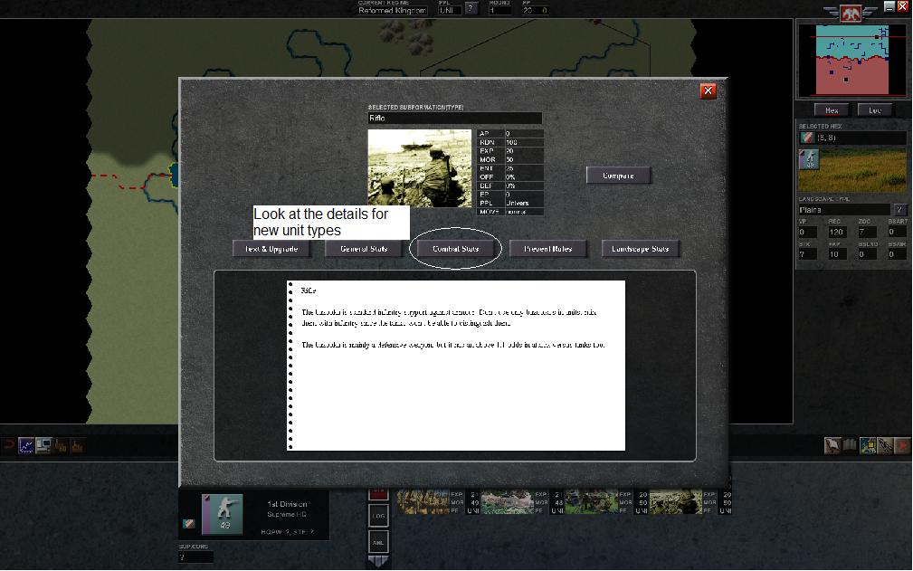
The attack and defensive strength of the bazooka unit is shown versus different classes of units. It is clearly a counter specifically to armor.


