First Tutorial

Subparagraph X
[In the Introduction section, refer those not familiar with Advanced Tactics to start with the tutorial.]
Welcome to the tutorial! From the main menu, click the “Load Scenerio” button, highlight “tutorial.AT2” in the Classic_Tutorial folder. Hit the “open” button. In advanced tactics you win by accumulating victory points. Victory points are held by troops. Troops are made by production centers and supplied by headquarter units. In this first tutorial, our objective is to take the enemy village (a production center) just over the border. After starting the first tutorial this is what you should see:
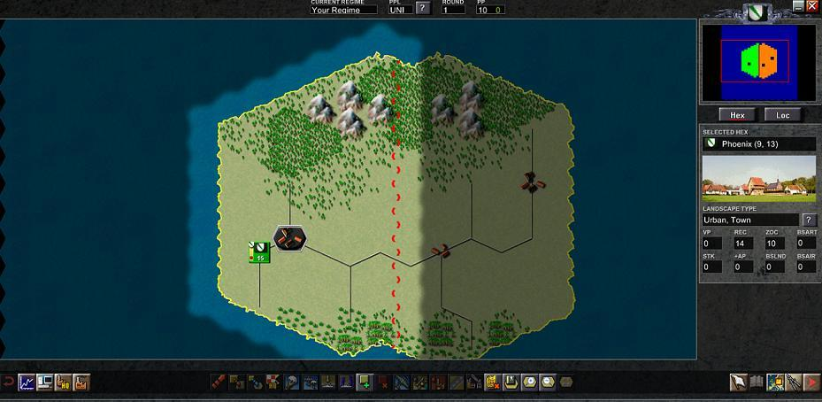
The town in your territory has a black background because it has not been assigned to a HQ yet. The green box just to its southwest is your HQ. Assign the town to your HQ by selecting the town, then select the button with a factory and “HQ” on it (fourth from the left on the line of buttons), then select your HQ unit.
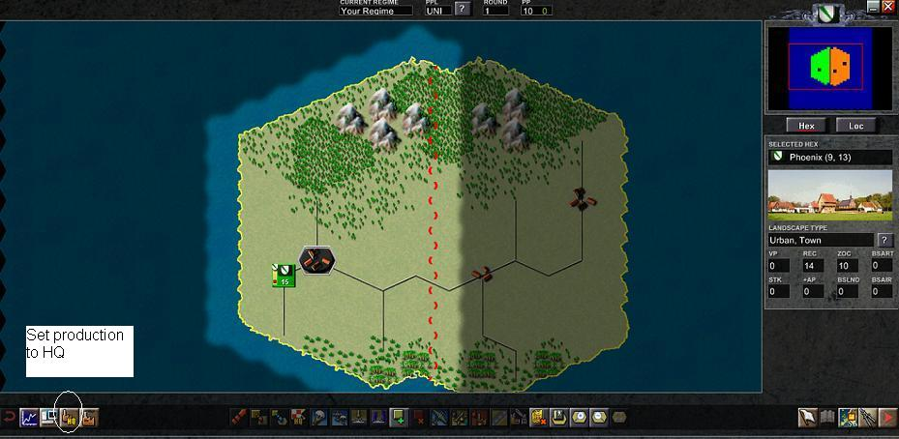
Finally click the confiming check button on the far right of the line of buttons. The town background should turn green, meaning that it is assigned and its production will appear in the assigned HQ unit.
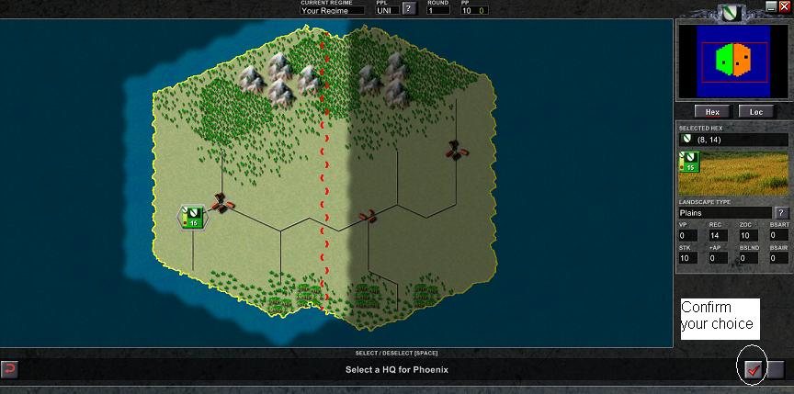
The shaded area to the east is enemy-controlled territory. The goal of this tutorial is taking the enemy village closest to our country. To do this we have to start producing some troops. Towns can produce troops. We have one town. Lets order it to produce troops! Select your town and then select the Production button (the factory button, fifth from the left in the line of buttons).
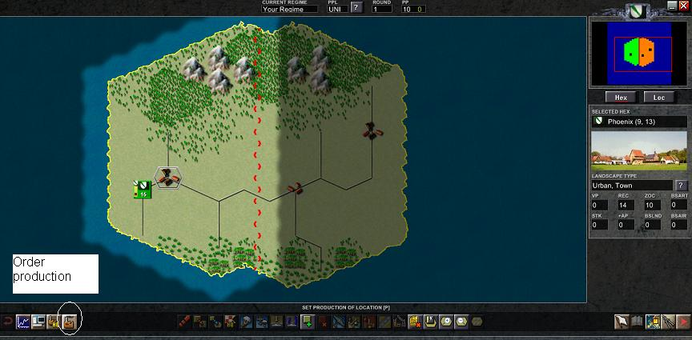
The production window then opens. Let’s produce some supply and some infantry.
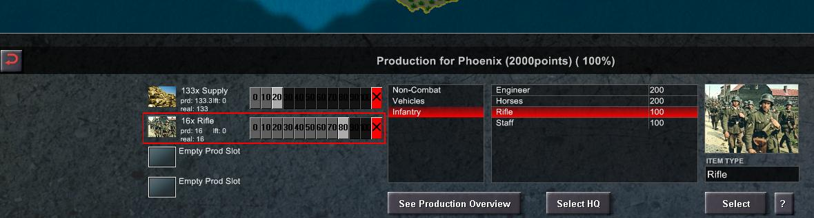
The four slots at left can be filled by what you wish to produce. Click an item from the list at right to set it to be produced; click the appropriate slot you wish to assign it to. Click the Select button to assign it. To the right of the slots is a row of boxes, which represent how much percentage of that town’s production should be set to that item. After you set the production of this town to 20% supply and 80% infantry, return to the previous screen by selecting the returning arrow button on the far left of the button line.
Double check your town assignment and production by selecting the town and looking at the hex description on the left of the screen.
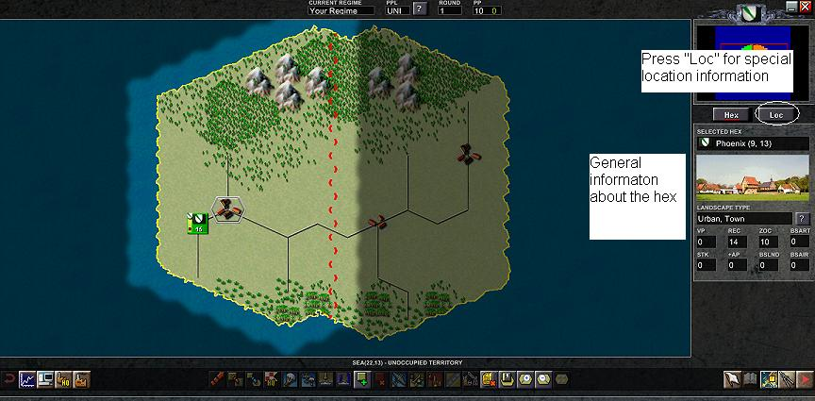
Click the button above this graphic labelled “LOC”. This screen should show what this production location is producing and which HQ it is assigned to.
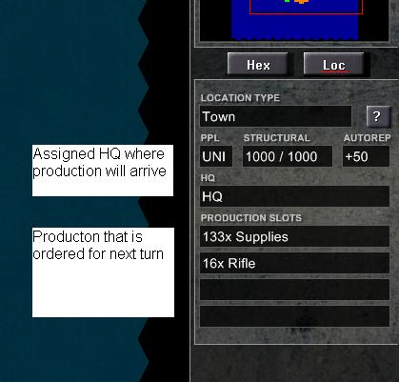
End your turn by hitting the button on the far right of the line of buttons.
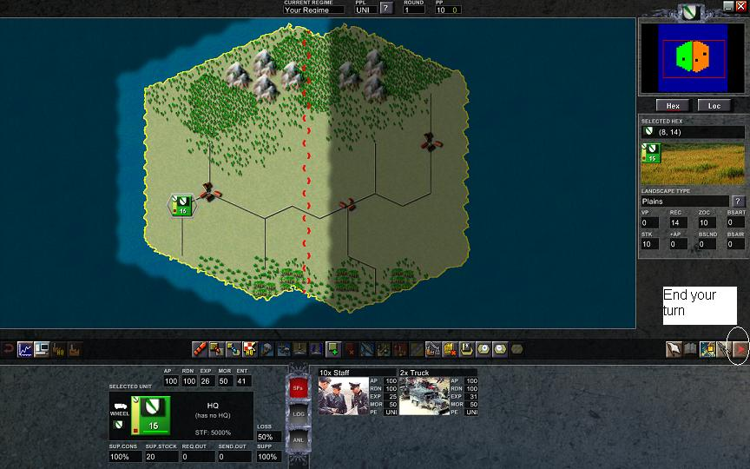
After the computer does some work, click “start”. Choose your HQ unit. Notice that 16 infantry units have arrived and that your available supplies have increased (in the previous screen the total was only 20). Also notice that in the previous screen, there is a red dot in the lower left corner of your HQ unit, while in the present screen, the light is green. Red means you have not received any new supply that turn (you are going to use your stored stock). Green means your stock of supply is increasing. If you run out of supply entirely, your units will starve.
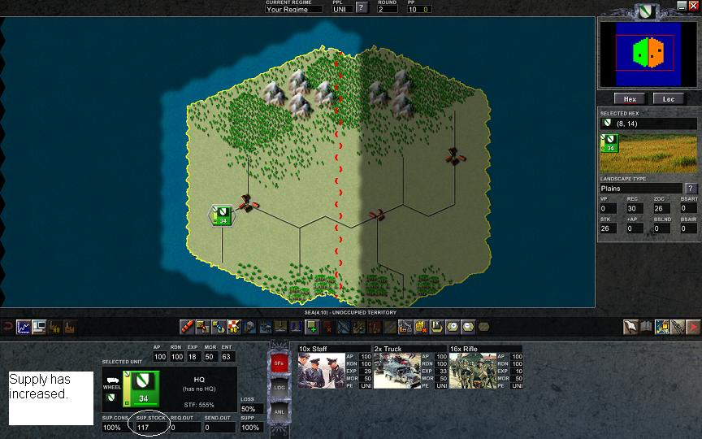
Next we will create an infantry unit near the front line. Select the road hex just before the enemy territory. Now click the “New Unit” button (green square with a “+” sign near the middle of the line of buttons).
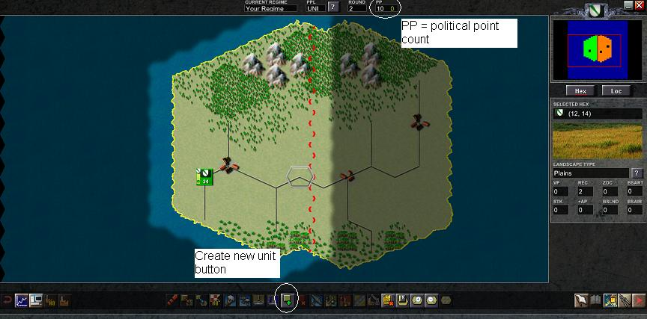
You are given the choice of creating a formation (cost is 1 PP) or a HQ (cost is 5 PP). PPs are political points, an abstract social cost of maintaining the military. PPs can be created by most prodution centers. They are used to create units and do research. At the top of the screen is a running talley of your political points (you have 10). Creating HQs are expensive in terms of PPs but useful on large maps. We will start making a formation for the HQ we already have. Click the “Formation” button and a formation box should appear in the chosen hex.
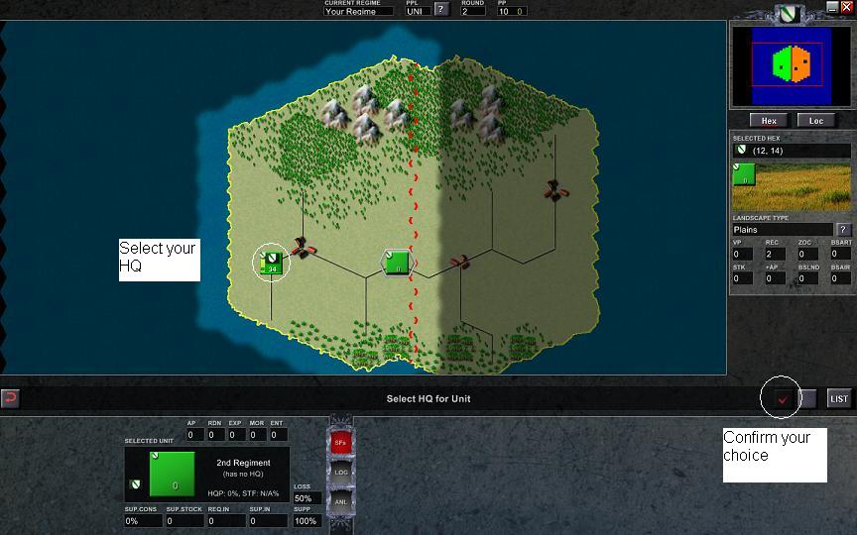
This formation is not assigned to our HQ yet, so select the HQ and then click on the confirming check button on the right of the button menu. Notice the formation gets a colored stripe that matches the HQ. This helps keep track of which formations are assocaited with which HQ. Now to fill the formation with troops. We can transfer units from the HQ. Start by selecting the HQ. Next click on the transfer button (marked with an orange diagonal dotted line near the middle of the line of buttons).
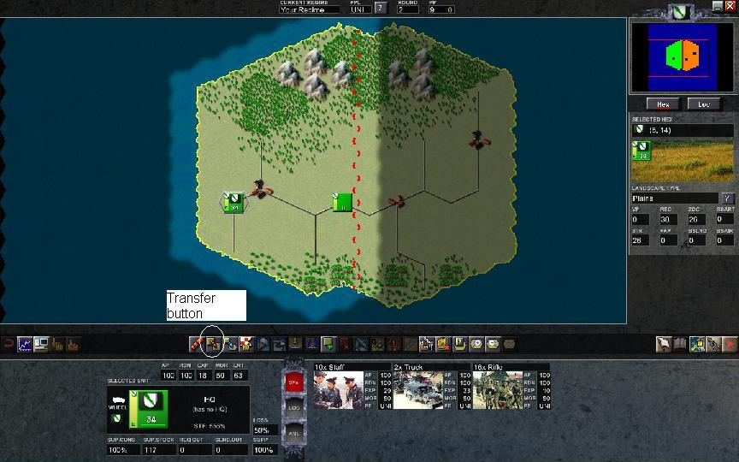
Next select our new formation and you will be able to select units in the HQ that you want moved to our front line formation. We choose to move rifle units. How many? Let's move all 16. Click the transfer button and all 16 should move from the HQ to Regiment 2. Don't press the “Transfer” confirmation box until you are certain about the number you want to send. Hit the returning arrow button (far left on the line of buttons) to return to the previous interface.
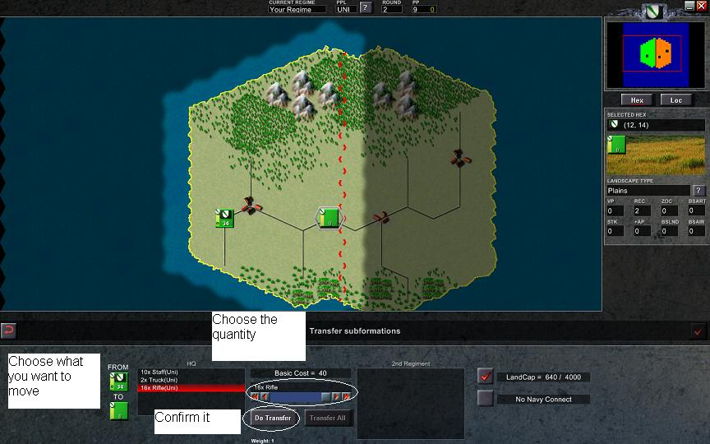
Let's look at our unit (select regiment 2). All these numbers mean something, we will start at the top. AP are action points. They determine how many actions (moving, attacking, etc) the formation can make. Since the formation was made this turn, it has no actions left. RDN is readiness. It is a measure of how organized the formation is. Since everyone just arrived this turn, they are not 100% organized. EXP is experience. All these men are fresh from boot camp so they are quite green. MOR is morale. They have average morale. ENT is entrenchment. The formation has made a few preparations to defend this position. The formation's SUP.STOCK is 32 and they have a green dot showing that they have enough bullets and beans for now. HQP is headquarters power. Because the HQ is some distance away, the communication with this unit is less than 100%. STF is staffing level. There are enough staff members in the HQ for a much bigger army. All these factors have an effect on the combat result. Once you get to know them, they can help predict how your unit will perform in a fight.
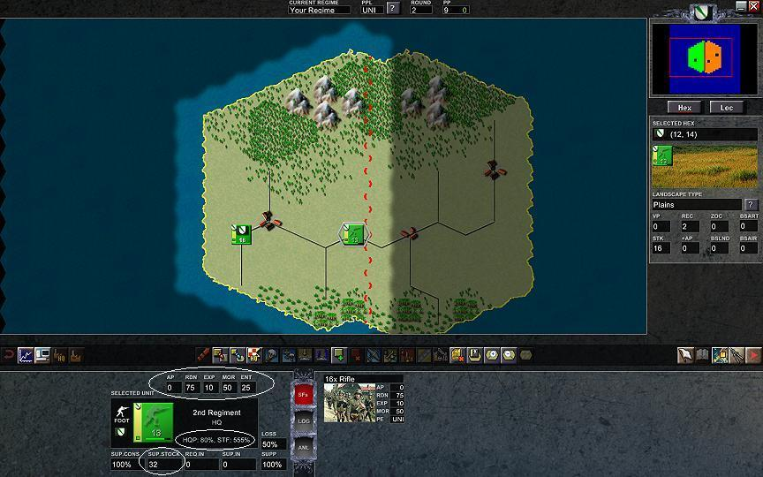
Since our front line unit cannot attack this turn. Click the end of turn button. Now at the start of turn 3, regiment 2 has 100 AP and we are ready to take that enemy village. Click on regiment 2 and select the “Move” button (with a large orange arrow, left middle of the line of buttons).
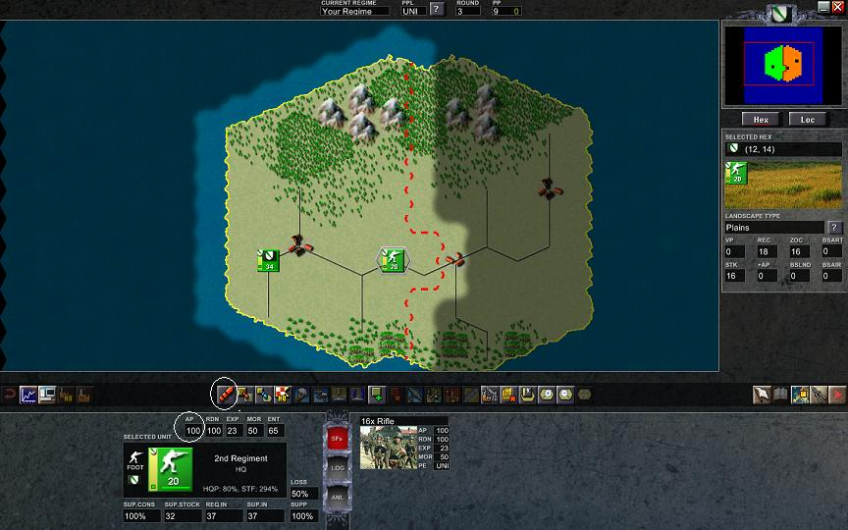
The area that regiment 2 can reach this turn is highlighted. Put your cursor over the village. Notice that the dialogue window reports that it will cost the formation 80 AP. Click on the village.


