Movecost + Stats in the Property Sheet Box
When this option is chosen, the Movecost for MoveTypes box will appear as well as four more buttons.
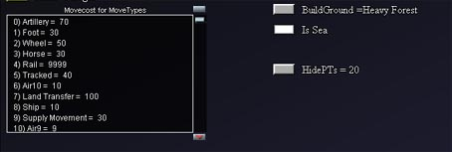

Movecost for MoveTypes Box
This box shows how many action points movement into a particular hex costs for each MoveType. Each subformation type is assigned a MoveType using the Movetype button in the SFT window of the Editor.

