The Landscape Layers Option in the Property Sheets Box
The Landscape Layers option … [An advanced user is needed to explain what this option does].
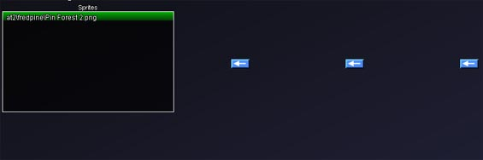

Landscape Layers Box in the Property Sheet Box
The Landscape Layers box lists the sprites associated with the chosen landscape type in the LandscapeTypes box.

Landscape Layers Box Buttons
When a landscape type in the Landscape Layers box is selected, three buttons appear.
Graphics Buttons These three unlabeled buttons modify how a sprite appears on the hex. The right-most button allows a graphic file to be chosen as the base sprite of the selected landscape type. The center button places an optional sprite on the underlying sprite to modify the underlying layer. The left-most button adds an additional graphics file- an over sprite- that extends slightly beyond the original hex. The over sprite is used to represent objects like the peak of a mountain that rises above the hex. [This is just a guess, an advanced user needs to explain this]

