Landscape Type Window
This Window is used to modify the landscape that is painted on the hexes.
When the land button is pressed, the initial window will have the LandscapeTypes subwindow and four buttons:
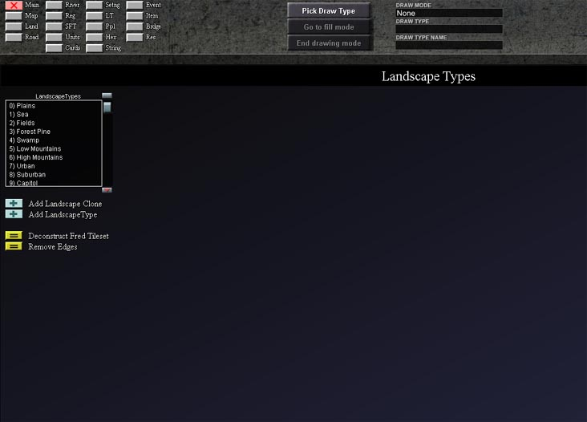

LandscapeTypes Submenu
This submenu contains all the landscape types that are currently available for the scenario. Additional landscape types can be created by using the Add Landscape Type button, which is described below.
Next, a landscape type from the LandscapeType submenu is then selected. This will add the property sheet submenu and many additional buttons to the Landscape Types window, which are explained below:
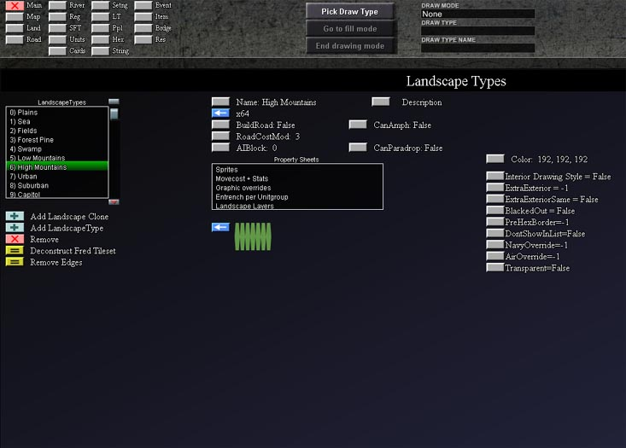

Property Sheet Submenu
Property Sheet Submenu is used to modify sprites used to represent landscape, the effect of landscape on unit movement and entrenchment. The specific details of this submenu available by clicking the link.

LandscapeType Buttons

Buttons Under the LandscapeType Submenu
Add Landscape Clone. This button will clone the selected landscape type. The landscape type must first be selected in the LandscapeType submenu. The new landscape type will have same name as the landscape type it was cloned from, and will be assigned the first available unassigned number for a landscape type. The cloned landscape can then be modified using the property sheet submenu
Add Landscape Type. This button creates a completely new landscape type. The definition of this new landscape be set up using the property sheet submenu.
Remove. Deletes the selected Landscape Type
Deconstruct Fred Tileset. [This will need a description from a knowledgeable user]
Remove Edges. [This will need a description from a knowledgeable user]

Buttons Above the Property Sheet Submenu
Name. This button allows the user to type in a new name for the selected landscape type.
X64. [This will need a description from a knowledgeable user]
BuildRoad. This button allows the user to specify whether or not a road can be built on the particular landscape type (true= road can be built; false = no road can be built.)
RoadCostMod. This button allows the user to specify a multiplier of the base price in engineering points for building a road. For example, if it costs 20 engineering points to build a road on a plain hex, a RoadCostMod of 2 would double the cost of engineering points to 40. [Is this correct?]
AIBlock. This button allows the user to create terrain that the Artificial Intelligence will avoid. (0 = Artificial Intelligence will not avoid terrain; 1 = Artificial intelligence will avoid terrain)
Description. This button allows the user to type in a description describing the landscape type.
CanAmph. This button allows the user to specify whether or not a an amphibious landing can be performed on the particular landscape type (true= amphibious landing can be performed; false = amphibious landing cannot be performed.)
CanParadrop. This button allows the user to specify whether or not a a parachute drop can be performed on the particular landscape type (true= parachute drop can be performed; false = parachute drop cannot be performed.)

Button Below the Property Sheet Submenu
Change Prehex Sprite [Unlabeled].

Buttons to the Right of the Property Sheets Submenu
Color.[This will need a description from a knowledgeable user]
Interior Drawing Style.[This will need a description from a knowledgeable user]
ExtraExterior.[This will need a description from a knowledgeable user]
ExtraExteriorSame.[This will need a description from a knowledgeable user]
BlackedOut.[This will need a description from a knowledgeable user]
PreHexBorder.[This will need a description from a knowledgeable user]
DontShowInList.[This will need a description from a knowledgeable user]
NavyOverride.[This will need a description from a knowledgeable user]
AirOverride.[This will need a description from a knowledgeable user]
Transparent.[This will need a description from a knowledgeable user]

