Simple Editor: Libraries
This is one of the most important tabs of the Simple Editor. Here you actually import all the kinds of libraries (trooptype, historical, event, etc..).
This is also one of the most complicated tabs to comprehend. So please sit down and take your time to read up on it.

Core interface
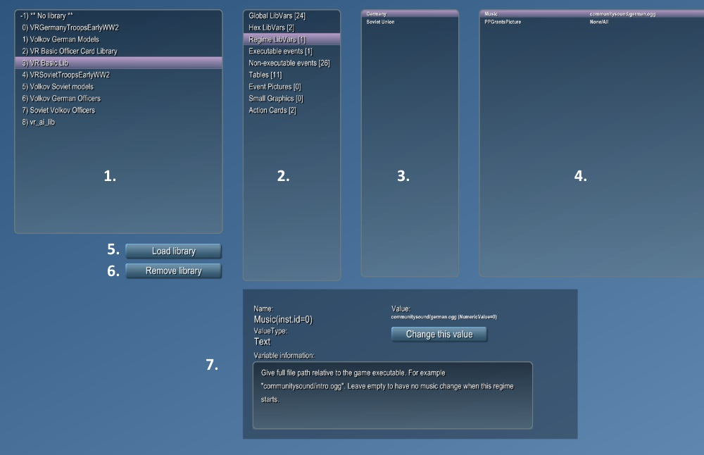
You see here in the top of the tab a maximum of 4 listboxes. These are:
1. Libraries loaded list Every library you will load will appear here.
If you click it you can inspect and configure its contents in the listboxes right of this one.
There is always an item on top here called 'No Library' and here all the data can be inspected that is non modular (not library based).
2. Content categories of selected libraries Each library can contain different kinds of data.
Here all the types of data present are listed. Each type can contain multiple instances. Click in this 2nd listboxes to see all the instances of the selected datatype for the selected library appear in listbox 3+4.
3+4. The data of the the selected libraries content category
Some data types use only listbox 3. Items here are often configurable. Others use listbox 3+4 and in that case the items in listbox 4 are often configureable.
5. Load Library
When you click it you can select a library file to (re)load.
Keep in mind that you can load different kind of libraries here and can set the kind you search for in the right-bottom corner of the file loading dialogue:
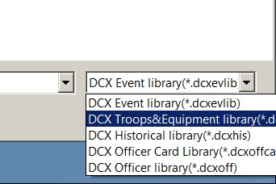
Once you select something the Load Library Popup will appear that will help you configure how to load the library.
Library Load Popup
6. Remove Library
Does exactly what it says. It removes the currently selected library. This means you'll lose all the data that was in it and that depends on it. If it for example you delete one of your historical unit libraries you will lose all units on the map that were set to one of the historical units/models defined in that library. So be carefull with removing libs.
7. Item info Here appears detailed info of the data instance you have selected.
Here you can also change the values of configurable values or data instances of the libraries.

What datatypes can appear in 2nd listbox?
===What

